MAIN PAGE
WPC (WOOD PLASTIC COMPOSITE) SIDING & SOFFIT
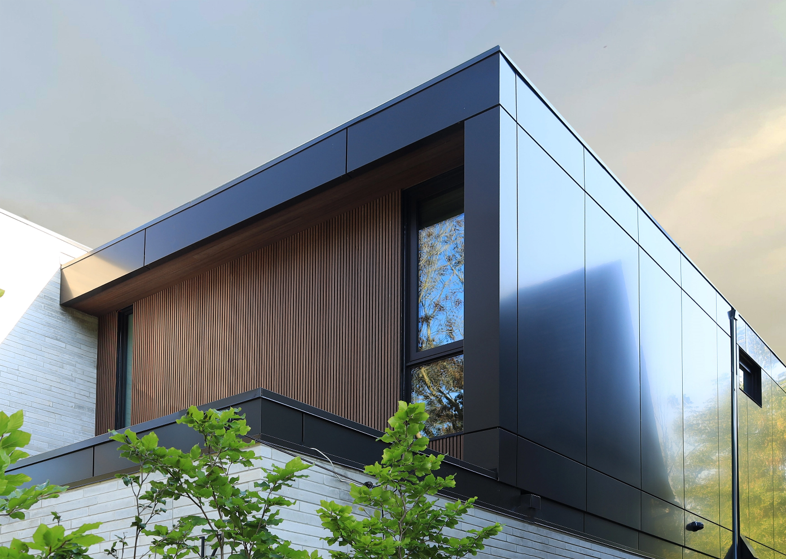
Industrial / Residential / Commercial / Agricultural
WPC Boards — Where Natural Beauty Meets Modern Innovation
WPC board is a type of composite material that combines wood fibers with thermoplastics. Compared to traditional wood products such as MDF boards, WPC boards have many advantages and can be used for various applications.
WPC (Wood Plastic Composite) board is a next-generation material that merges wood fibers with thermoplastics to create a durable, weather-resistant, and low-maintenance solution for a variety of applications. Unlike traditional wood-based products like MDF, WPC offers superior strength, longevity, and adaptability, making it an excellent choice for both interior and exterior projects.

Why Choose WPC?

Built to Last
WPC boards are engineered to resist moisture, rot, warping, and insect damage — making them an ideal choice for demanding environments, from harsh winters to humid summers.

Virtually Maintenance-Free
Forget constant sanding, sealing, and repainting. WPC retains its appearance with minimal upkeep, saving time and maintenance costs over the long term.

Sustainably Engineered
Made from recycled materials, WPC is an environmentally conscious alternative to conventional lumber — without compromising on durability or beauty.

Versatile for Any Project
Whether you’re designing sleek outdoor cladding, stylish indoor wall panels, or functional fencing and decking, WPC delivers consistent performance with a high-end finish.

Enhanced Aesthetics
Thanks to advanced manufacturing techniques, WPC boards replicate the natural grain, warmth, and colour variations of real wood — all while offering a broader selection of tones and finishes that stay vibrant for years.

The Ideal Upgrade to Traditional Wood & MDF
While MDF swells, weakens, and deteriorates in moisture-prone environments, WPC remains stable and reliable, even in exposed exterior conditions. It’s the smart solution for designers, builders, and homeowners who demand more from their materials.
Speak with an Expert Get personalized advice and expert guidance to achieve your project goals with confidence.
WPC SIDING & SOFFIT (PREVIEW)

WPC DECORATIVE BEAMS- ICON
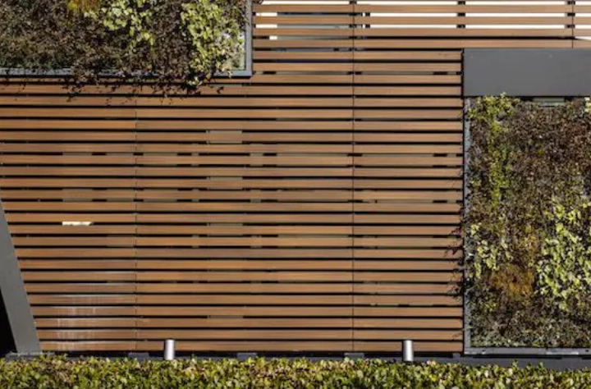
Modern Style. Zero Maintenance. Unlimited Possibilities.
Bring striking architectural detail to your project with our premium composite wood beams crafted to deliver the warm look of real wood with none of the upkeep.... (Learn More / Expand)

WPC DECORATIVE BEAMS (EXPANDED)
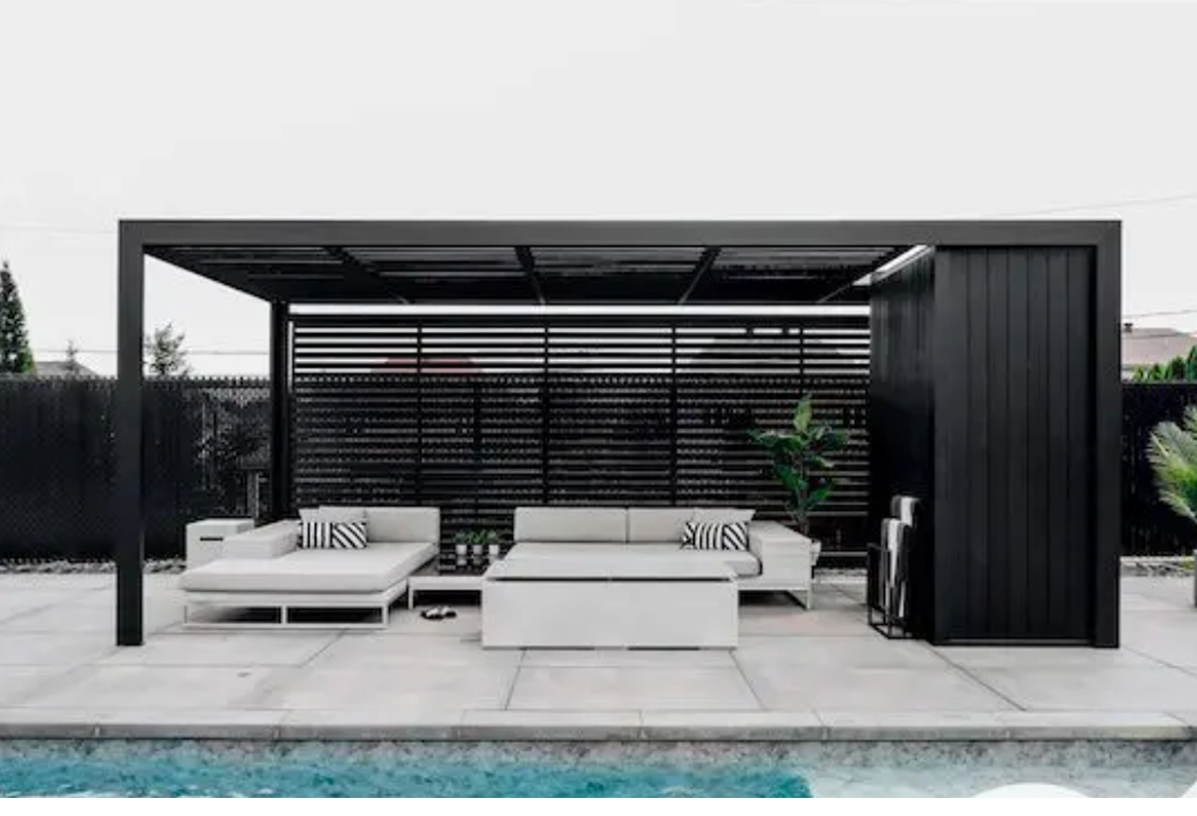
Expanded … Modern Style. Zero Maintenance. Unlimited Possibilities.
Bring striking architectural detail to your project with our premium composite wood beams crafted to deliver the warm look of real wood with none of the upkeep.
Designed for decorative use, these privacy screen louvers are ideal for adding depth, texture, and bold character to facades, soffits, pergolas, ceilings, and more.
Made from the high-performance material, each beam is encased in durable UltraShield® capping for superior resistance to fading, moisture, insects, and mold. The result: a long-lasting, maintenance-free finish that looks flawless year after year.

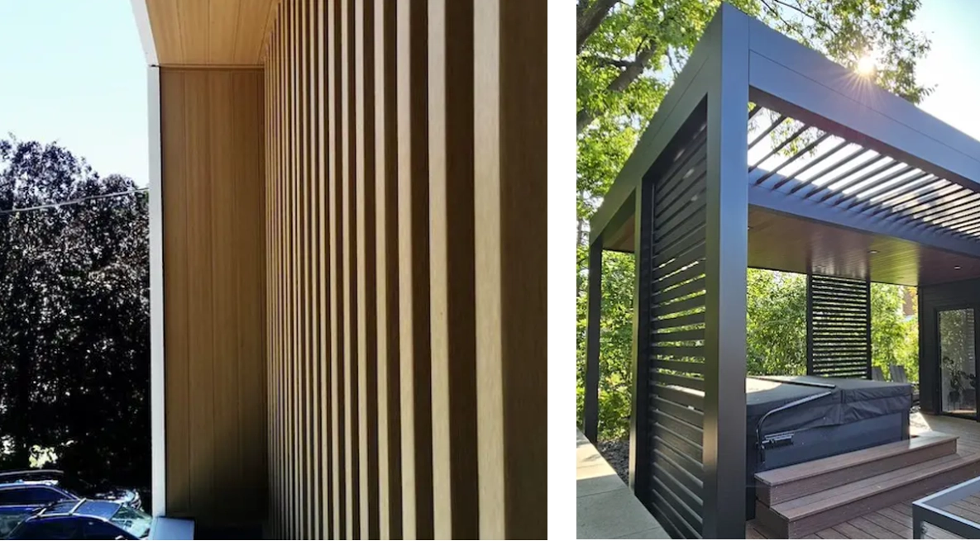
Design-Driven Versatility
From sleek modern builds to more rustic or transitional designs, these beams blend seamlessly into a wide variety of architectural styles. Their clean lines and natural textures create dramatic plays of light and shadow, making even the simplest structures visually impactful.
Whether you’re framing an entrance, highlighting a roofline, or adding ceiling detail, our decorative beams offer unmatched creative flexibility—giving designers and builders an easy way to elevate exterior or interior spaces.
Please Note: These beams are non-structural and must be securely fastened at a maximum spacing of 4 feet.

Profile Options:

2.4” x 1.7” 3.9” x 2” 4.7” x 2.4”
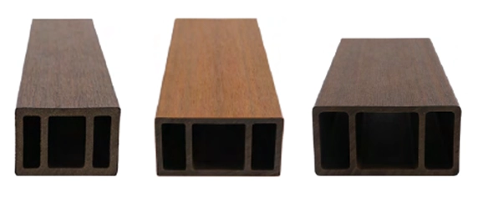

Finish: Brushed
Available Lengths: 10 ft, 12 ft and 16 ft
Installation Options: Horizontal and Vertical

Trims
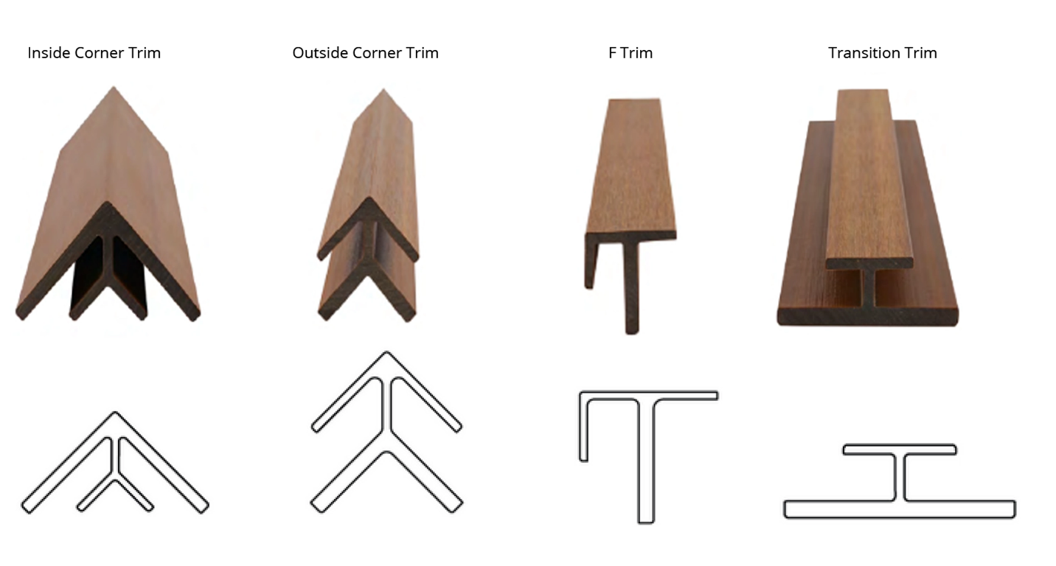
Finish: Brushed
Available Lengths: 10 ft and 16 ft

Available Finishes

